**Name: Vijay Vishnu p b**

**Roll No:49**

**Batch:b**

**Date:21-03-2022**

**NETWORKING & SYSTEM ADMINISTRATION LAB**

**Experiment No.: 1**

**Aim**

Install the latest version of Ubuntu on an Oracle VM VirtualBox.

**Procedure**

**Step:1 install virtual box**

**Step:1.1 click next**

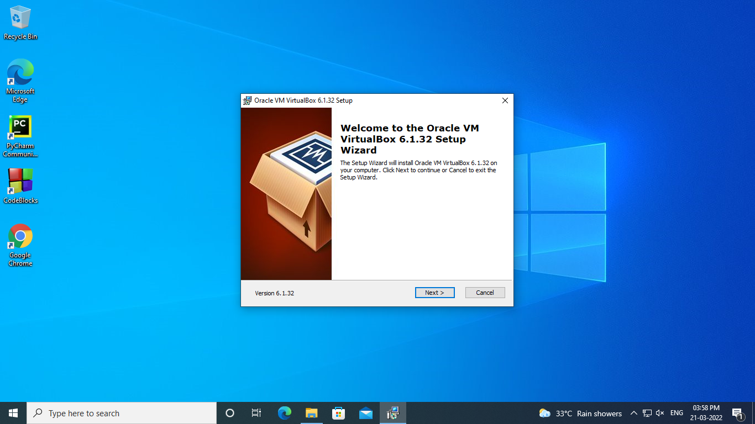

**Step:1.2 click yes**

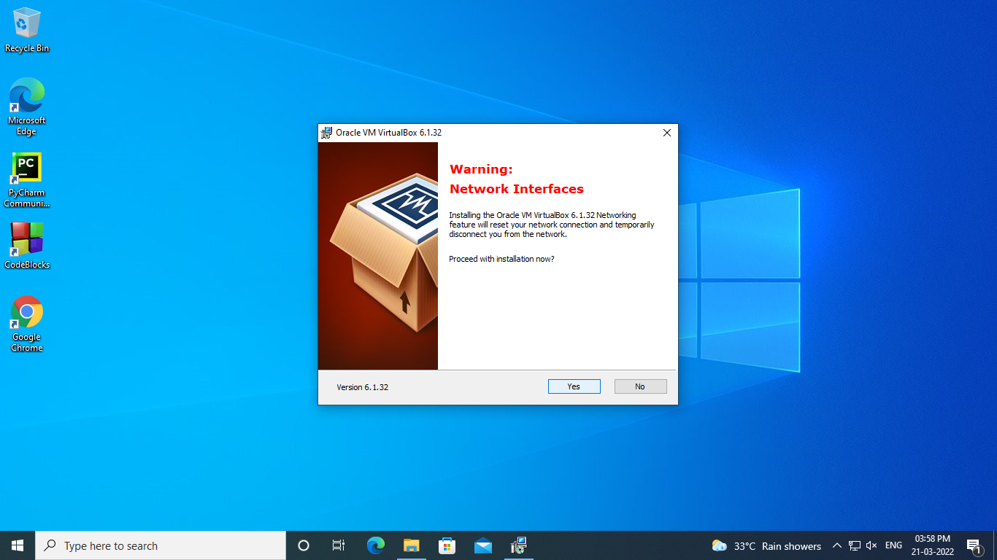

**Step:1.3 click install**

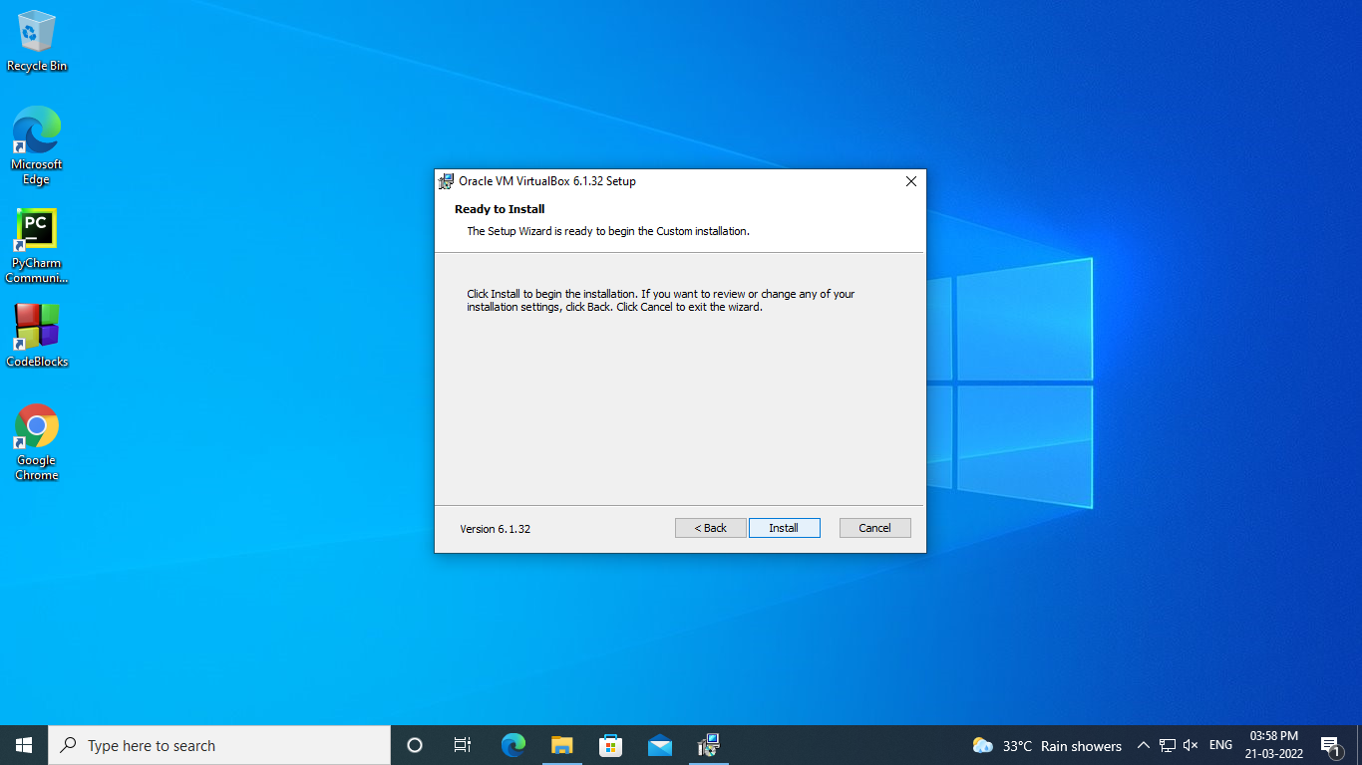

**Step:1.4 click on finish**

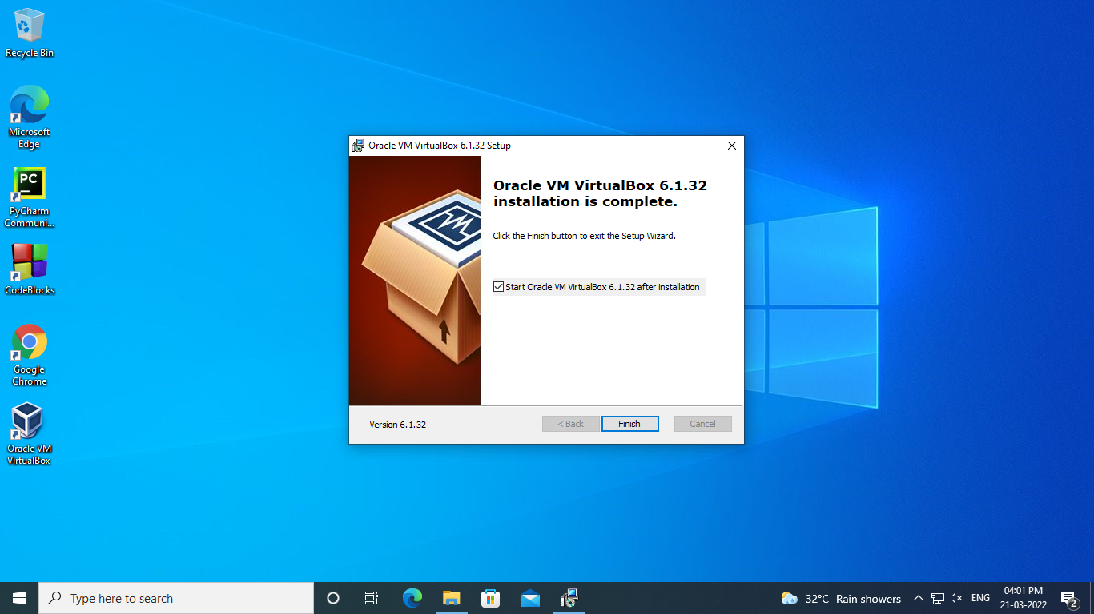

**Step: 2 click on new to add os to virtualbox**

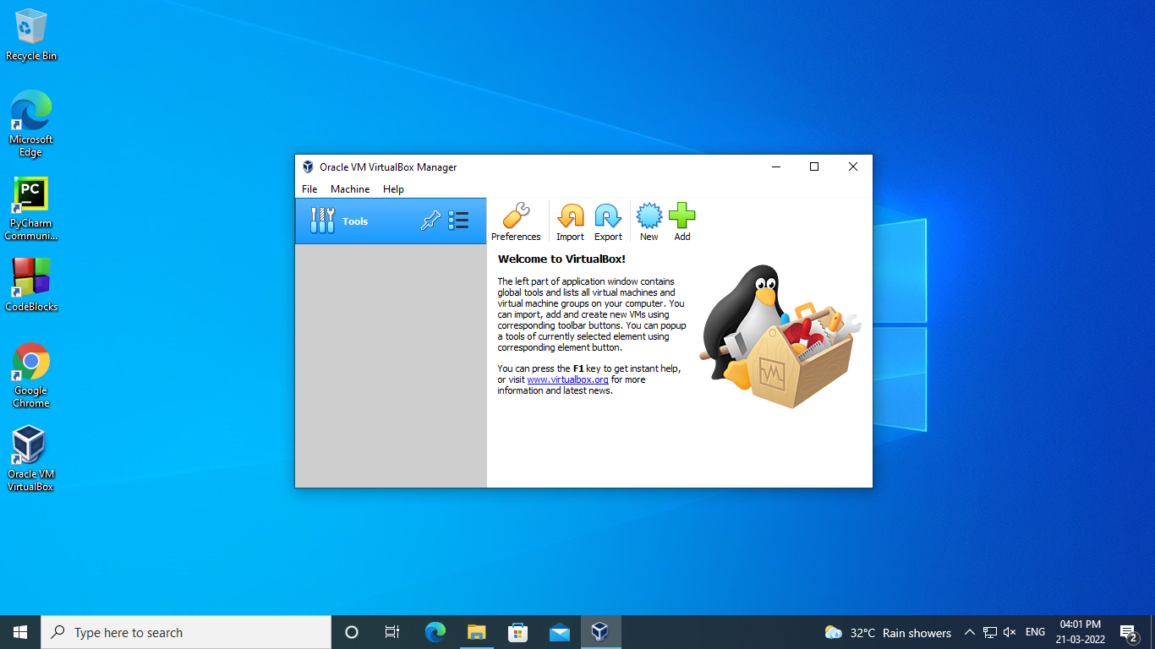

**Step:3 assign a name to the os**

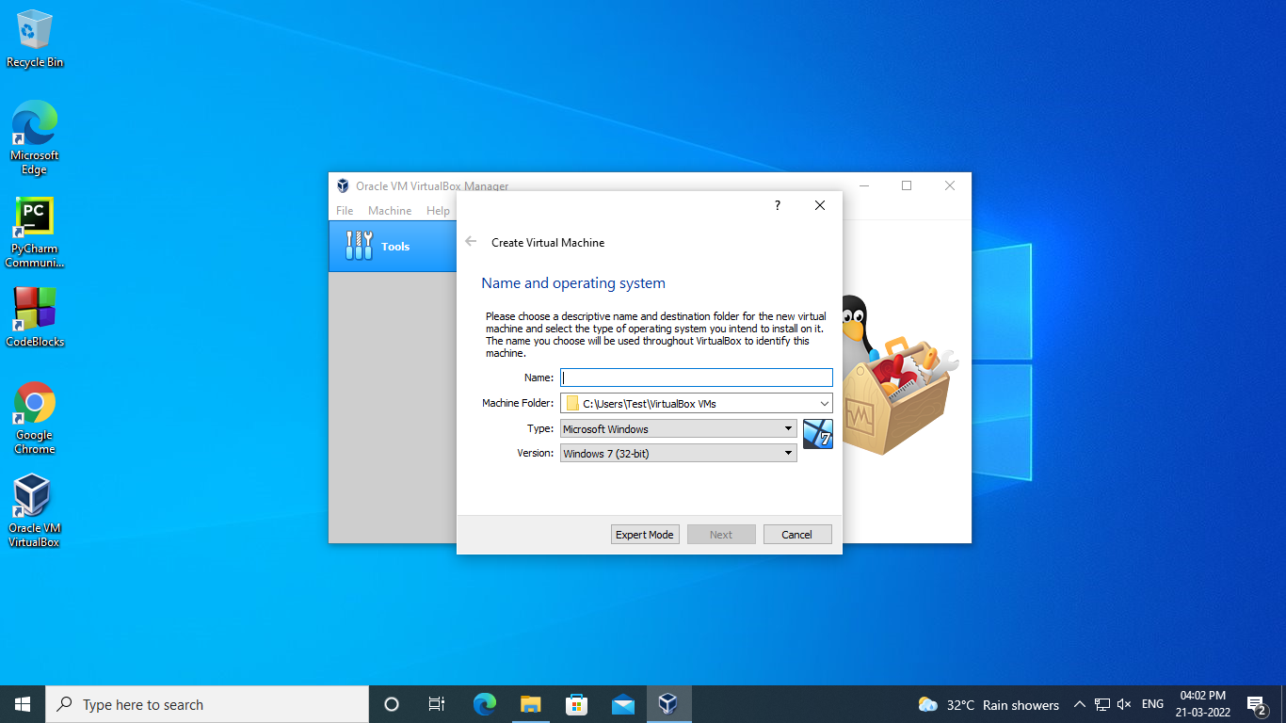

**Step:4 assign the memory**

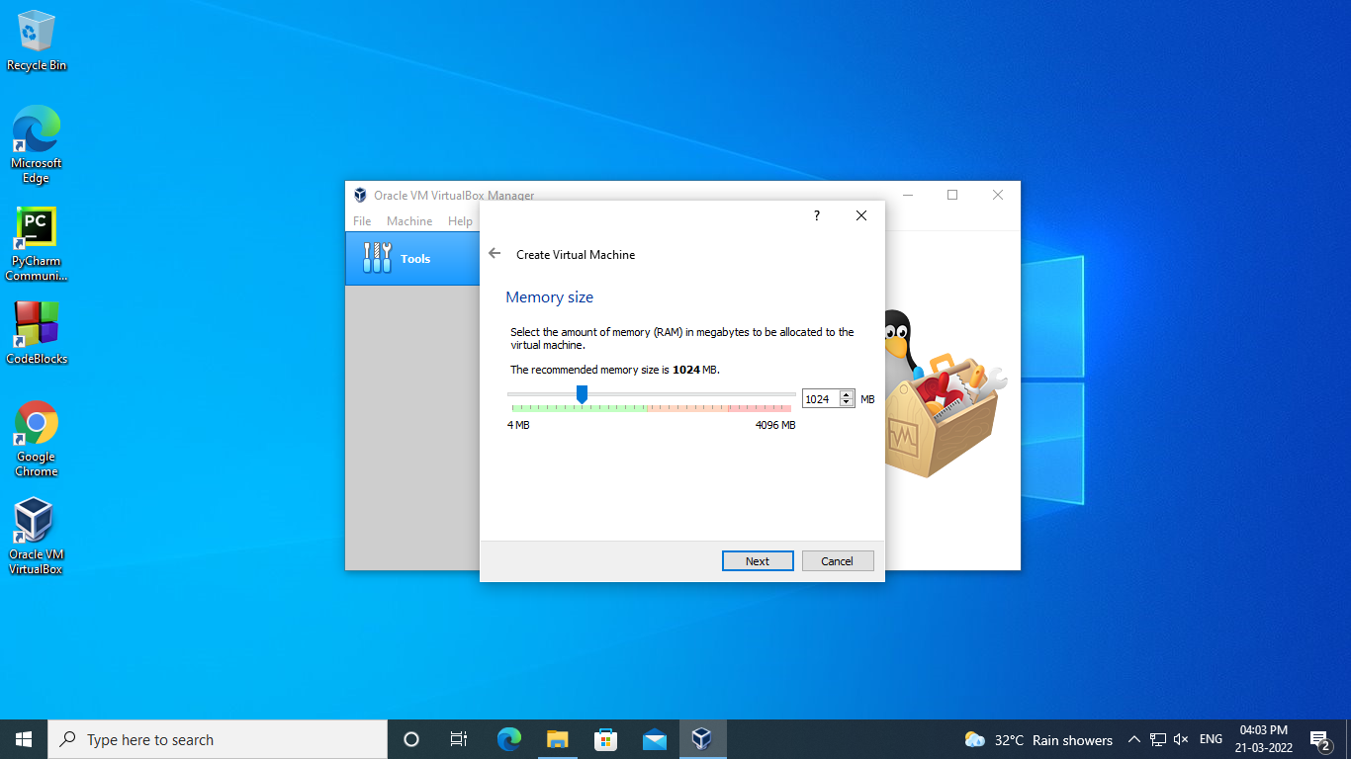

**Step:5 click on create virtual hardisk**

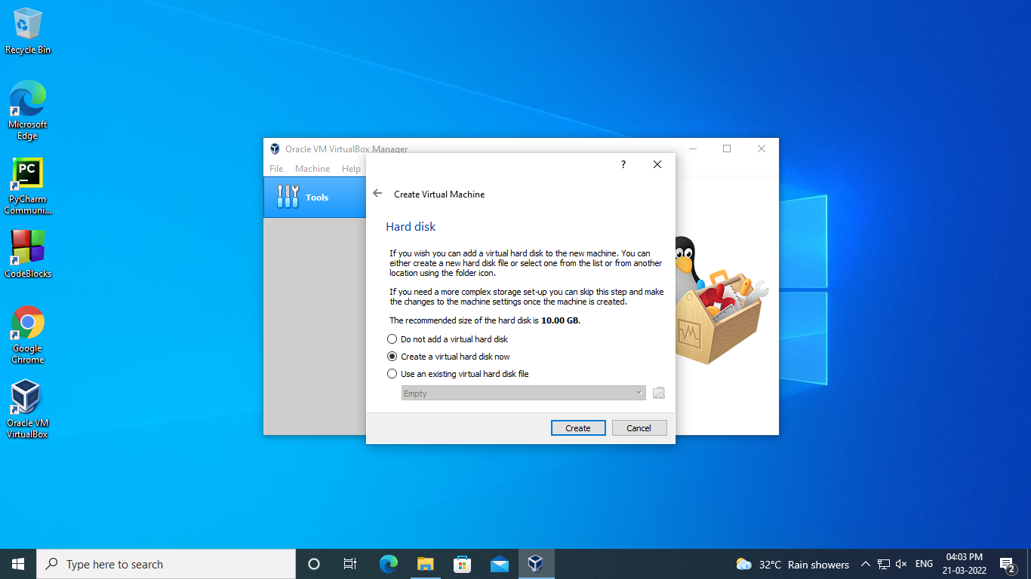

**Step:6 click on VHD option**

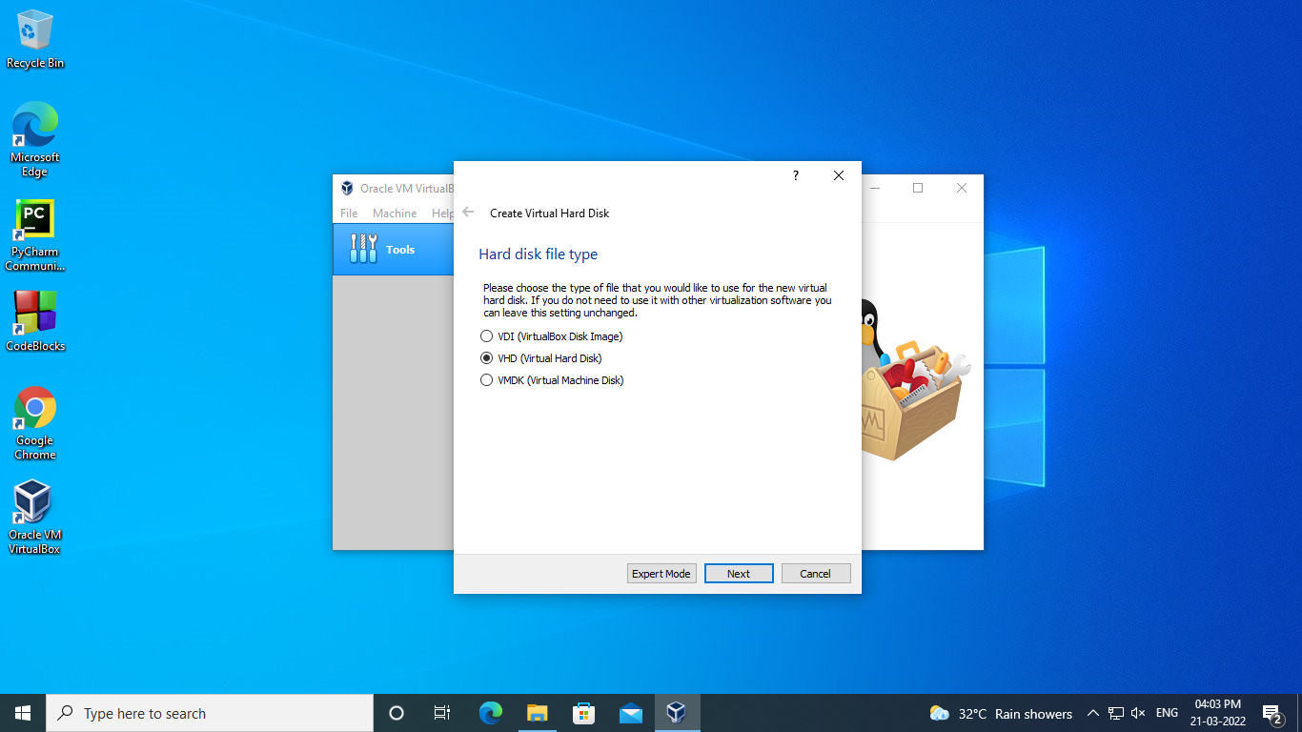

**Step:7 click on dynamically allocate**

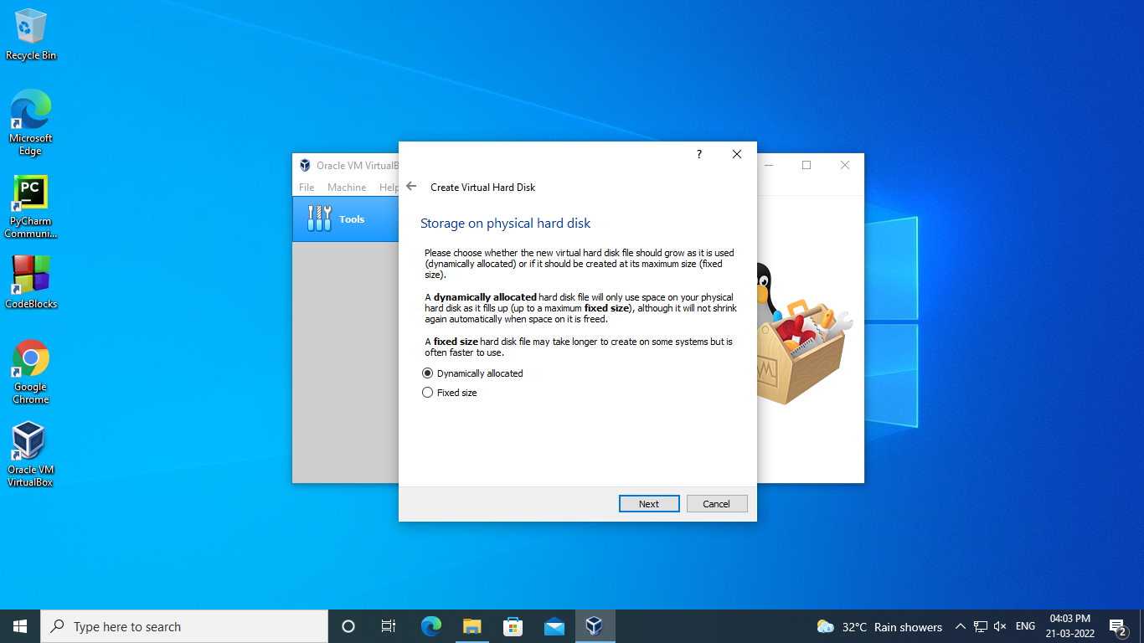

**Step:8 choose file location and size**

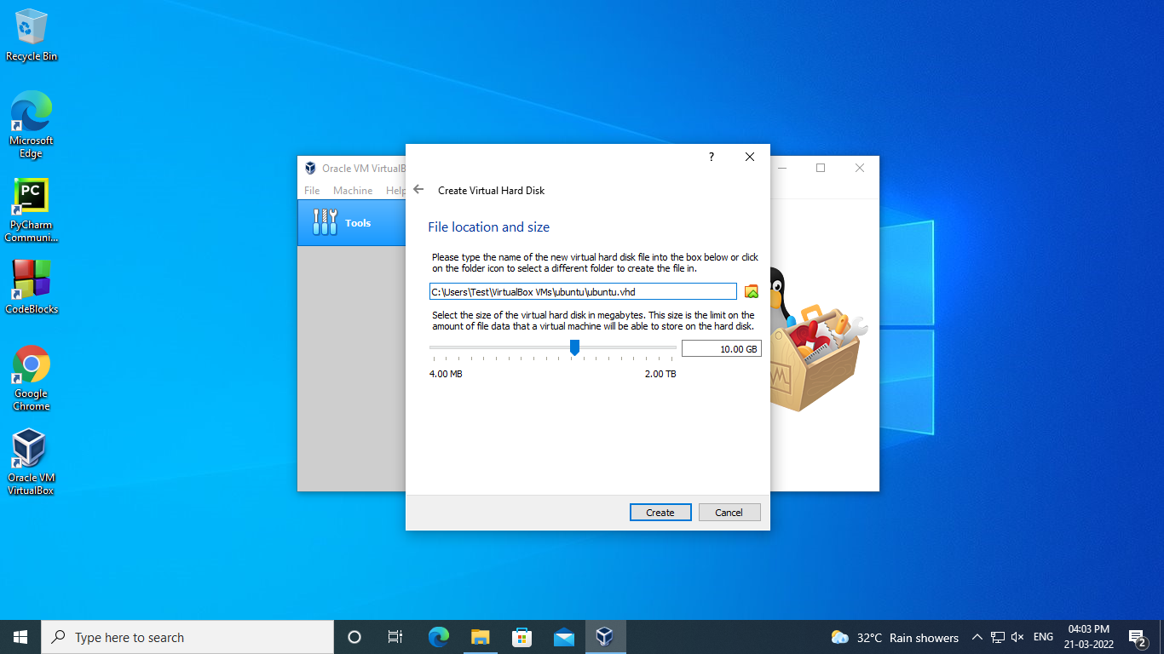

**Step :9 click on storage**

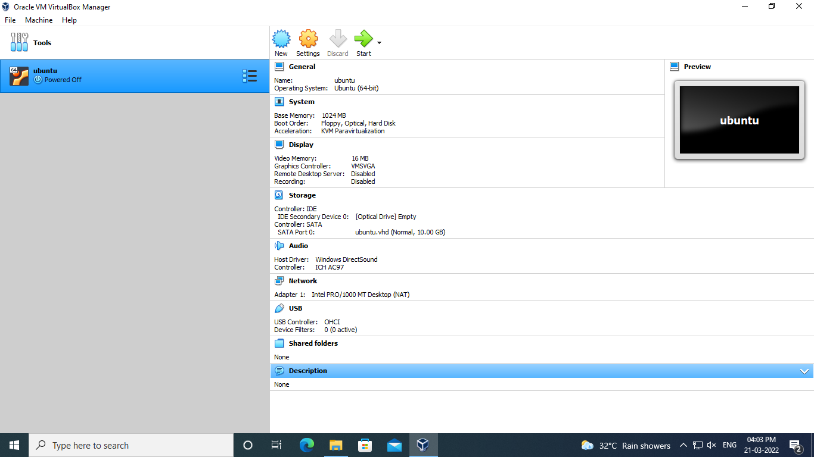

**Step:10 click on the disk to choose os**

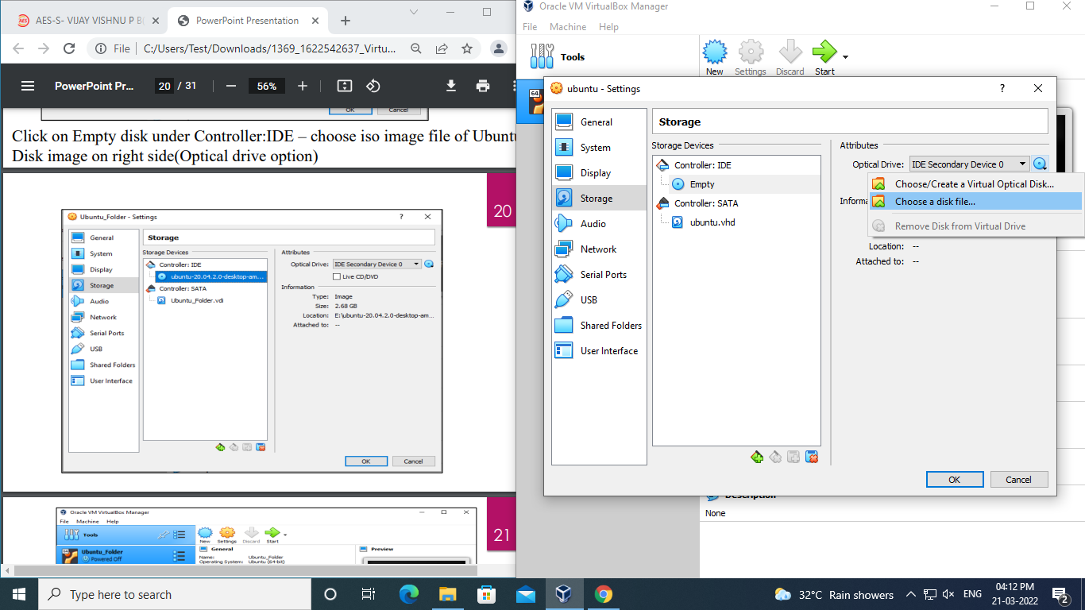

**Step:11 click on start**

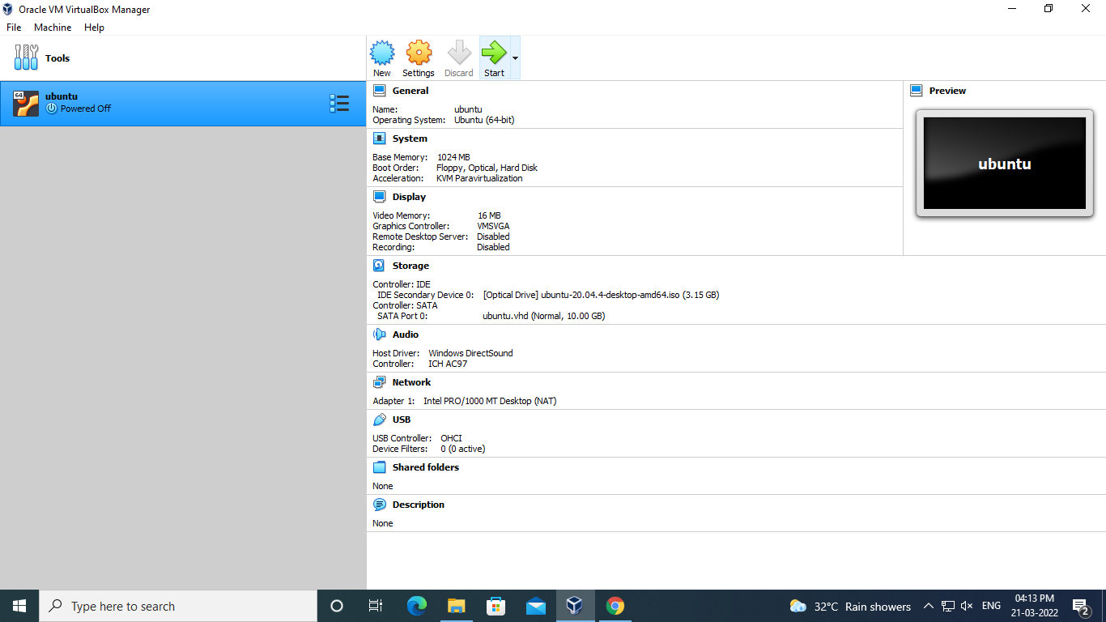

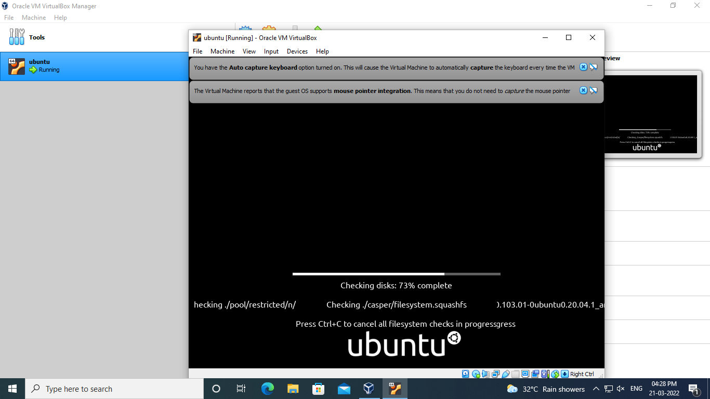

**Step:12 click on install Ubuntu**

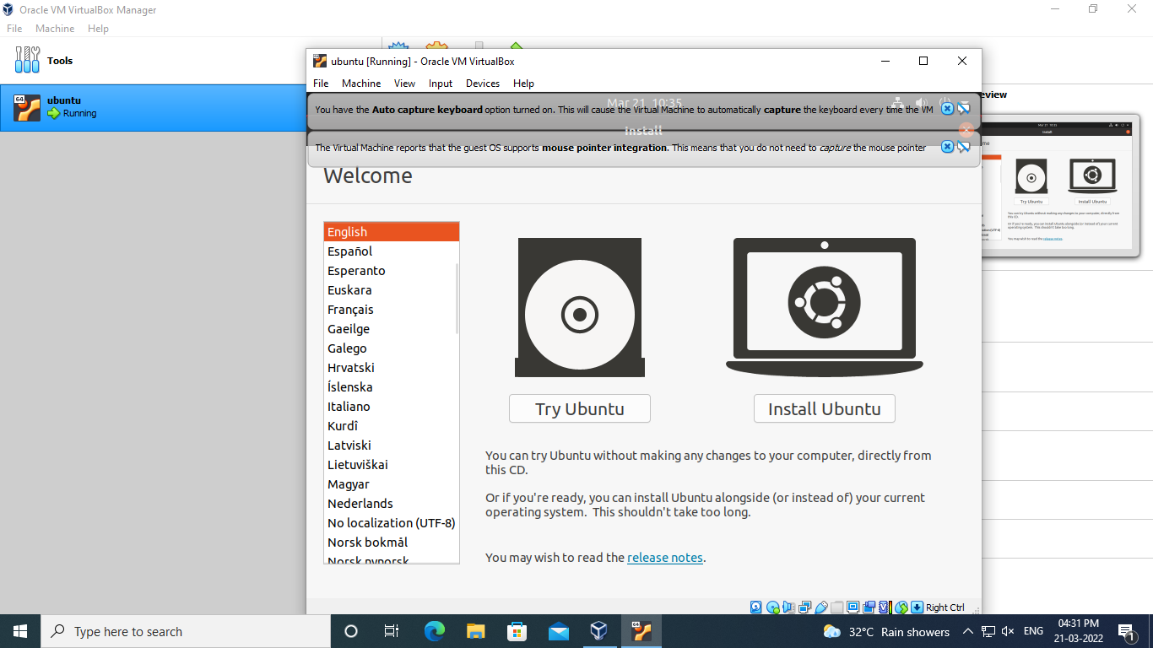

**Step:13 choose keyboard layout**

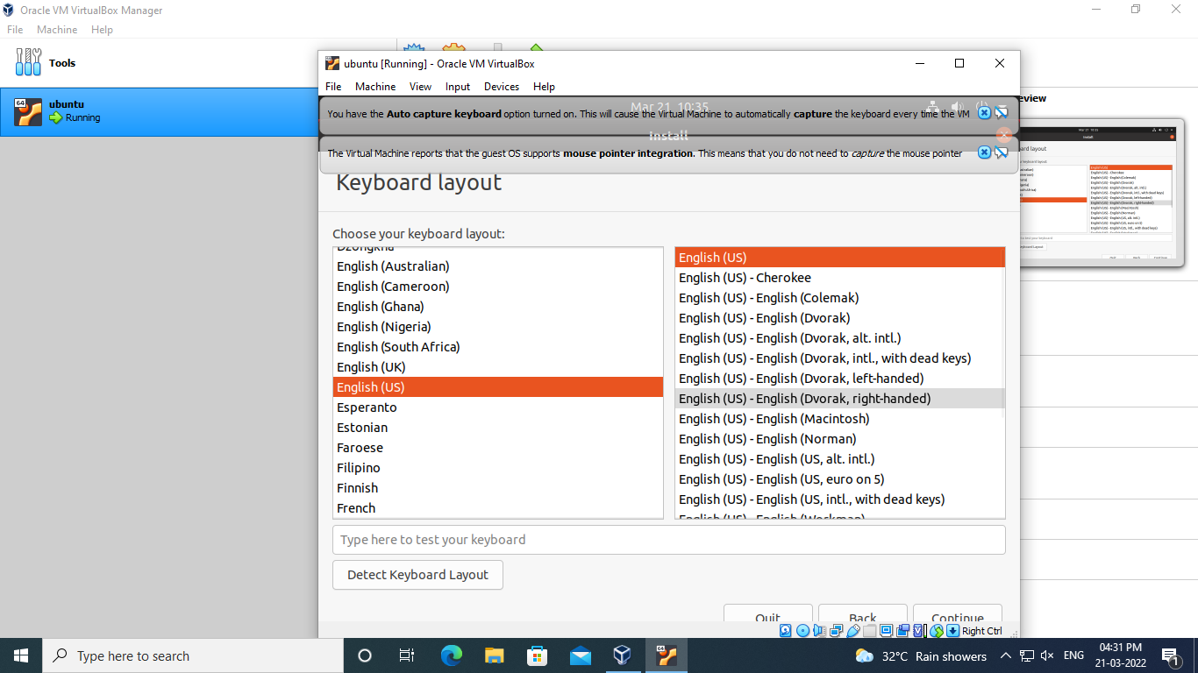

**Step:14 updates and other software**

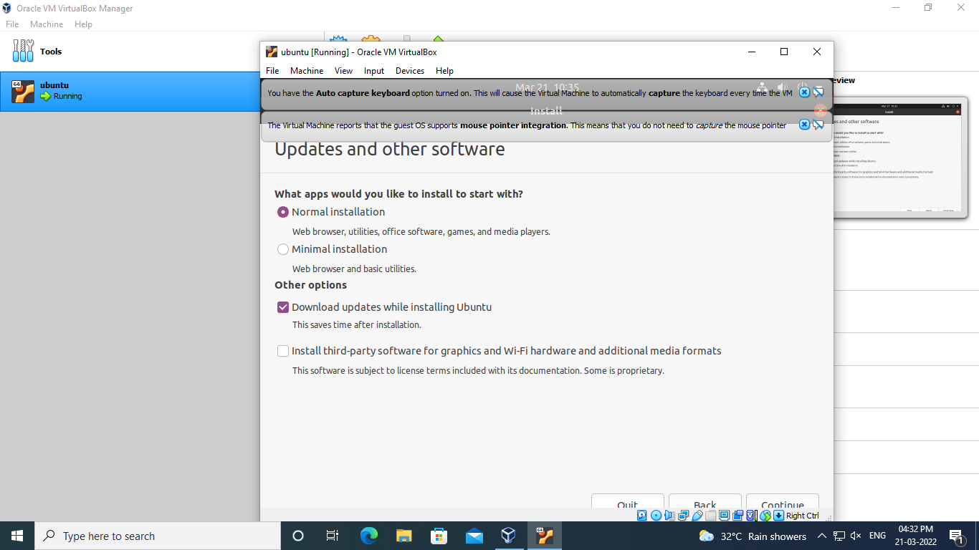

**Step :15 choose installation type**

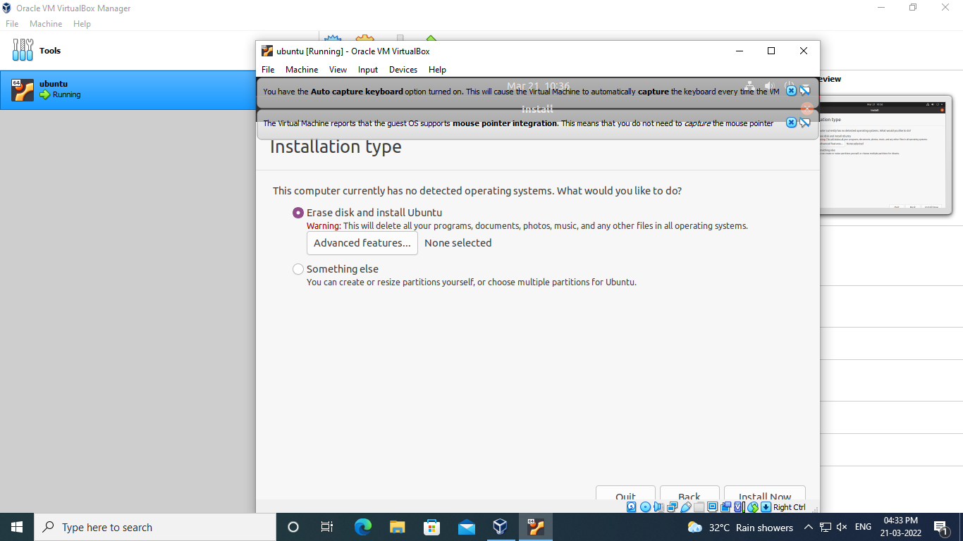

**Step :16 choose region**

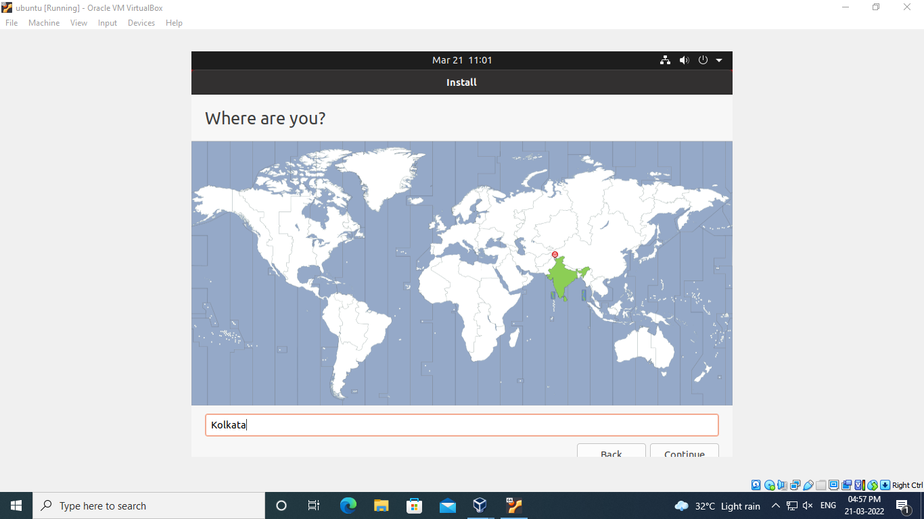

**Step:17 fill out the information**

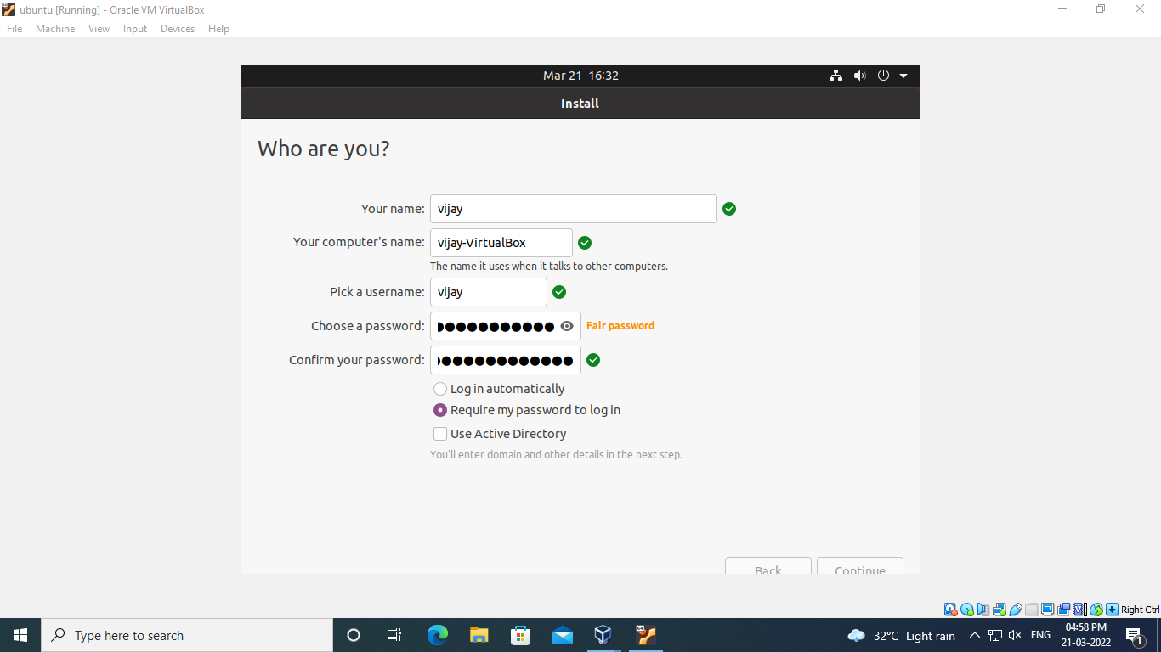

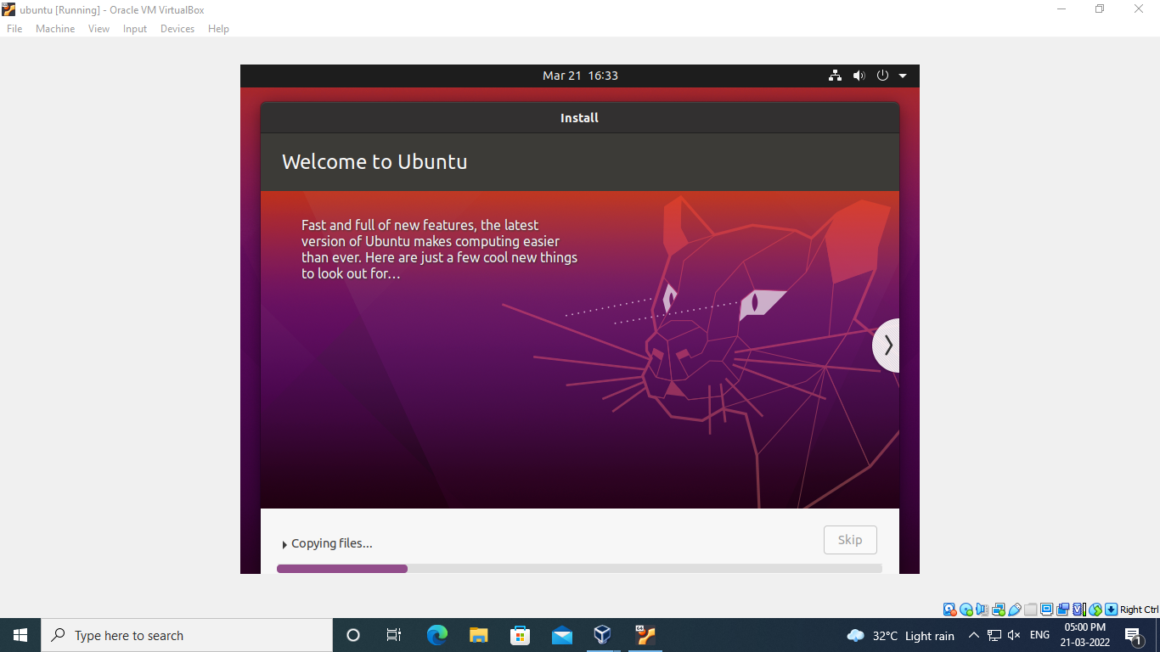

**Step:18 click on restart now**

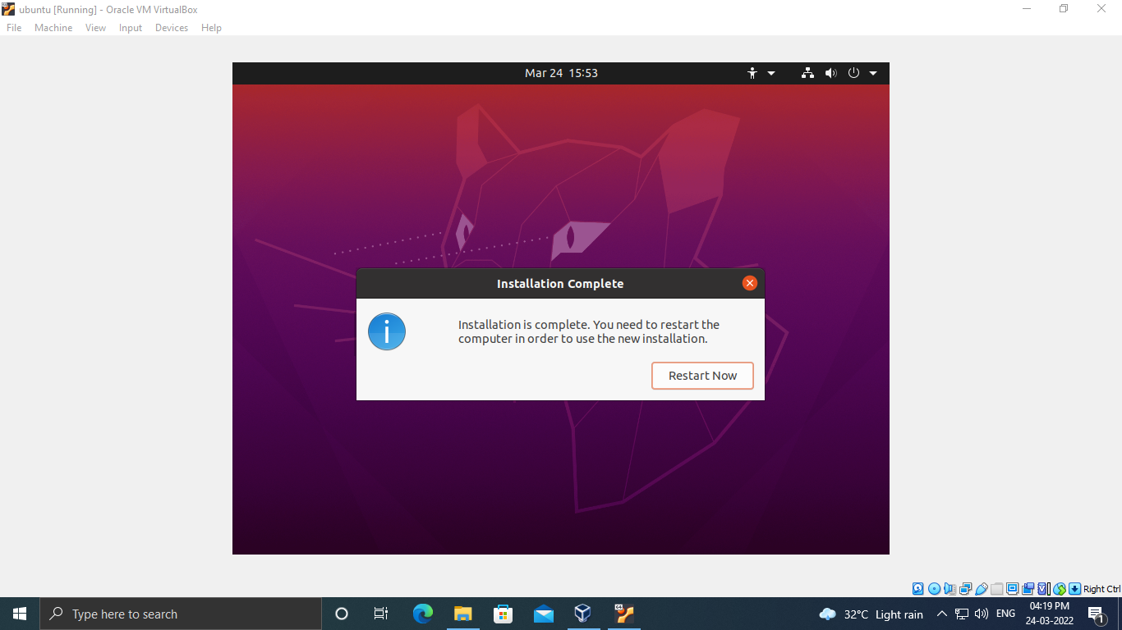

**Output Screenshot**

